 | Input | Expected | Actual | P/F
  Attempt
1 | Blank for both username and password | Invalid input | Invalid input | P
2 | Ctrl + c | Program end | Program end | P
3 | Numbers instead of user and password | Invalid input | Invalid input | P
4 | Actual user and password | Access granted | Access granted | P

Attempt 1 screen shot:
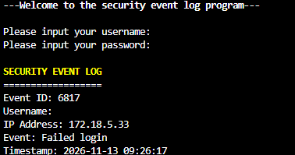

Attempt 2 screen shot:
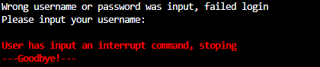

Attempt 3 screen shot:
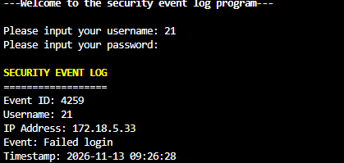

Attempt 4 screen shot:


